



The task with setting up a new database for a Library Management System
LAB MANUAL

Disclaimer: The content is curated from online/offline resources and used for educational purpose only
The task with setting up a new database for a Library Management System
Objective:
To design and implement a database system for a Library Management System that facilitates efficient management of books, members, and transactions. The objective is to:
- Create a database structure to store and manage book, member, and transaction data.
- Ensure data integrity and optimize queries using appropriate constraints, relationships, indexes, and schemas.
- Provide mechanisms for tracking active loans and book returns.
- Enhance data retrieval performance through indexing and efficient query design.
Problem Statement:
Libraries often face challenges in managing their operations due to the lack of a centralized and efficient database system. Key issues include:
- Book Management: Inability to maintain an accurate record of available, issued, and returned books.
- Member Management: Difficulty in tracking member details, such as membership status and borrowing history.
- Transaction Management: Inefficiencies in recording transactions (e.g., book issues and returns), which can lead to errors in identifying overdue books.
- Performance Issues: Slow search and retrieval of information due to lack of optimization in the database structure.

Requirements:
- MySQL Server installed and configured.
- MySQL client tool such as MySQL Workbench or CLI access.

Procedure:
A) Create a database named LibraryDB to store all relevant information
1. Open MySQL Command Line or Workbench
Open MySQL Workbench and connect to your MySQL server.

2. Create the Database
SQL command to create a new database named LibraryDBM

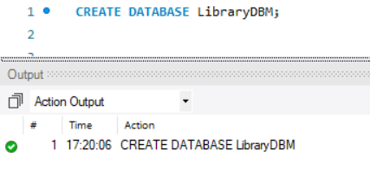

3. Verify the Database
To confirm the database has been created
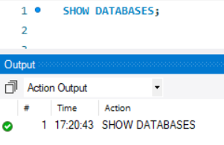
4. Select the Database
To start using the LibraryDB database, run
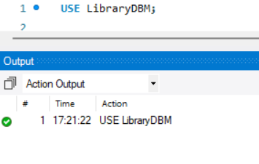
Step B: Create the Books Table
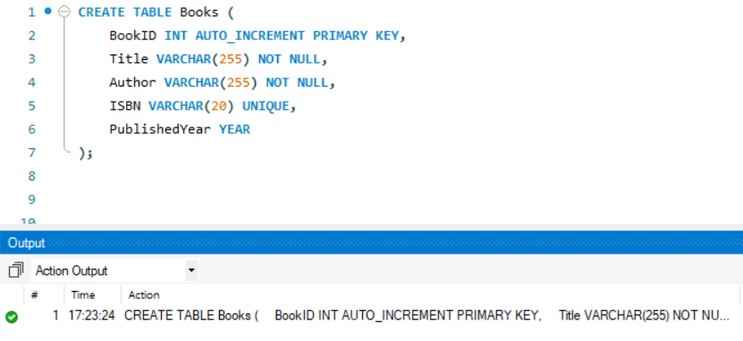

Step C: Create the Members Table
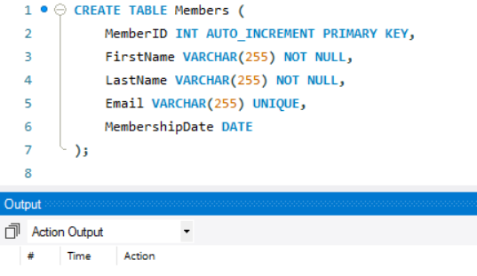

Step D: Create the Transactions Table
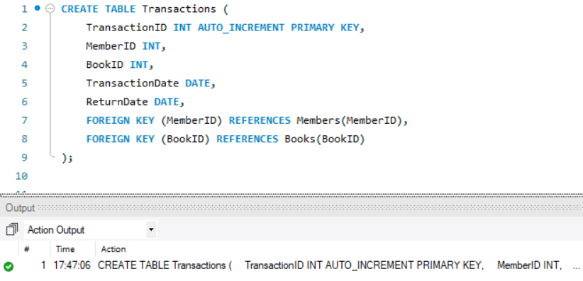

Step E: Create the ActiveLoans View

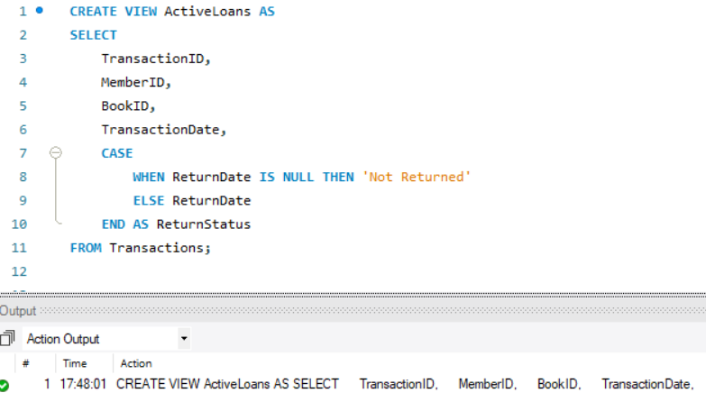
Displays all transactions with their return status. If ReturnDate is NULL, it shows "Not Returned".

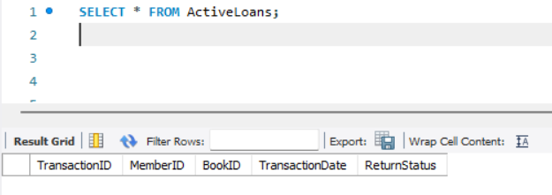

Step F: Create an Index on the Title Column
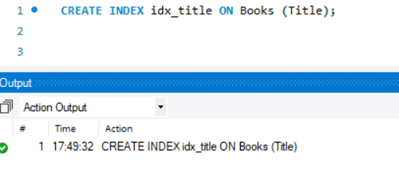

The index idx_title speeds up search operations on the Title column in the Books table.

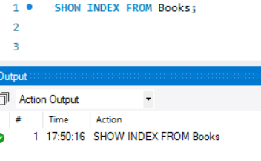

Step G: Create the Inventory Schema
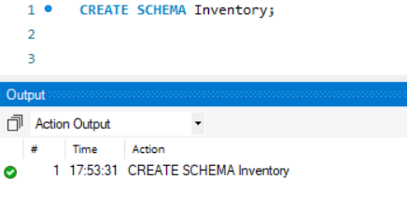
Inventory schema is used to organize tables and objects related to books and their details.

Step H: Create the MembersManagement Schema


MembersManagement schema is used to manage member details and their transactions.

Output:
The queries was successfully executed

